Pokhara University

Level: Bachelor | Semester: Spring | Year : 2014
Programme: BE |  | Full Marks: 100
Course: Logic Circuit |  | Pass Marks: 45
 |  | Time : 3hrs.

Candidates are required to give their answers in their own words as far as practicable.
The figures in the margin indicate full marks.

Attempt all the questions.

 | - Define positive and negative logic system. “Digital circuits are easier to design than analog circuit.” Do you agree with this statement? Give reasons to support your answer.  - Find the value of X.  - (777)_{x} = ( 212 )₈  - (DEC)_{H} = (0101)_{x}  - $(563)_{7}=$ (X)₃  - $(100111)_{Gray}=\left( X\right)Binary$ | 7  8
 | - State and Prove De-Morgan’s Theorem. List out the factors to be considered while constructing the Logic Gates.  - What is Don’t care condition? Simplify given function using K-map with circuit design.  F(W,X,Y,Z)=Σ(1,4,5,6,12,14,15) and don’t care condition D(W,X,Y,Z)= Σ (10,11). | 7  8
 | - Define universal gate. Design the three bit EX-OR circuit using only Universal gates.  - Design a combinational circuit that accepts a 3 bit number as input and generates the output binary number equal to the 2’s complement of input number. | 7  8
 | - Show how a full adder can be converted to a full substractor with the addition of one inverter circuit.  - Implement the following :  - F(A,B,C)= ∑ (1,3,5,6) ( using MUX)  - F1=∑(0,2,5) F2=∑(3,4,7) F3=∑(6,7) (using ROM) | 7  8
 | - Realize the following state diagram into a circuit using j-k flip-flop.  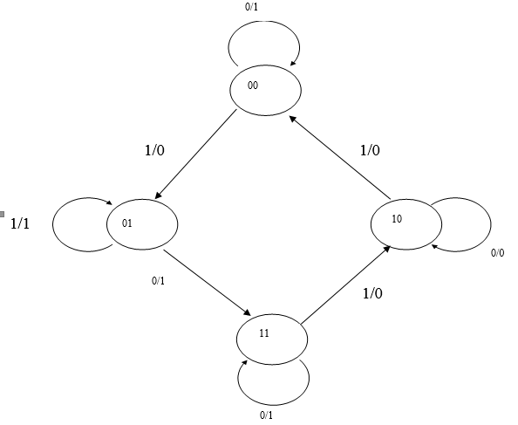  - Describe read and write operation in RAM with diagram. Draw a circuit for 6-bit SIPO shift register. | 8  7
 | - Design an arithmetic circuit with one selection variable and two data inputs A and B, When S= 0, the circuit performs the addition operation F = A+B when S= 1, the circuit performs the increment operation F= A+1 (only show the block diagram).  - Design a 4-bit arithmetic circuits which performs eight different arithmetic operations. | 8  7
 | Write short notes on: (Any two)  - Master slave flipflop.  - Nibble Adder.  - PLA. | 2×5

